Victoria Confeiteiro 2/23/2017

Lab 6

The difference between LEFT OUTER JOIN and RIGHT OUTER JOIN is the order in which the tables are looked at. In a LEFT OUTER JOIN Postgres looks at all the rows from the first table in the query first, and joins them with the second table in the query. In a RIGHT OUTER JOIN Postgres first looks at the second table in the join statement, then joins the first table in the query. While this is a small difference it can yield very different results. An example using the CAP4 database is when you join the Orders table with the Customers table. Below are screenshots of the JOINS and their results.

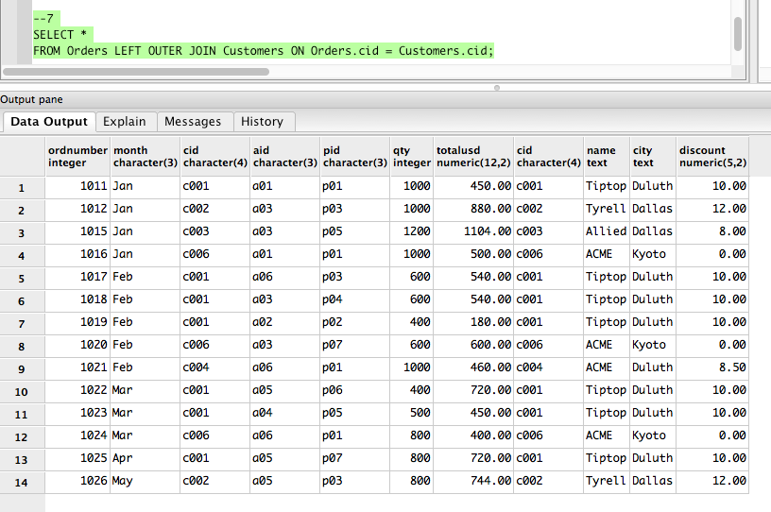

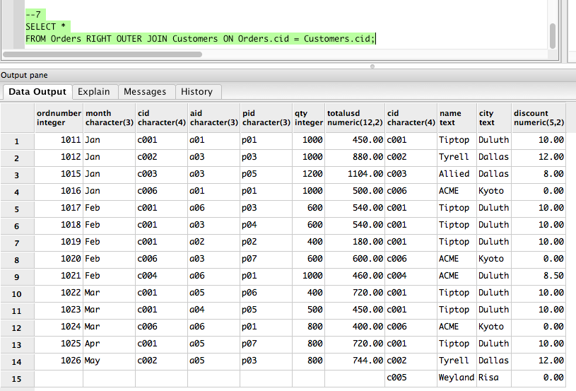

As you can see, the right outer join includes Customer c005, even though that customer has never purchased anything. This is because this join is looking at the Customers table first and displaying this table, then joining it with the orders table.